Implementation of a State Machine
(Pre-Lab Report)

Ho, Hingkei SID: 103 079 575
Vega, Roberto Javier SID: 003 110 717
CS152A / EE116L
PRE-LAB 2, Sec 4 T.A. Wendong, Hu

This laboratory involves the implementation of a pattern recognizer system. The system is actually Moore type machine, because the output not only depends on the input but also of the state of the machine; and at the same time an important observation is that the output is 1 exclusively when the up-coming state is “S5”. For all the other cases, the output is 0. Therefore the problem can be simplified with this state diagram:

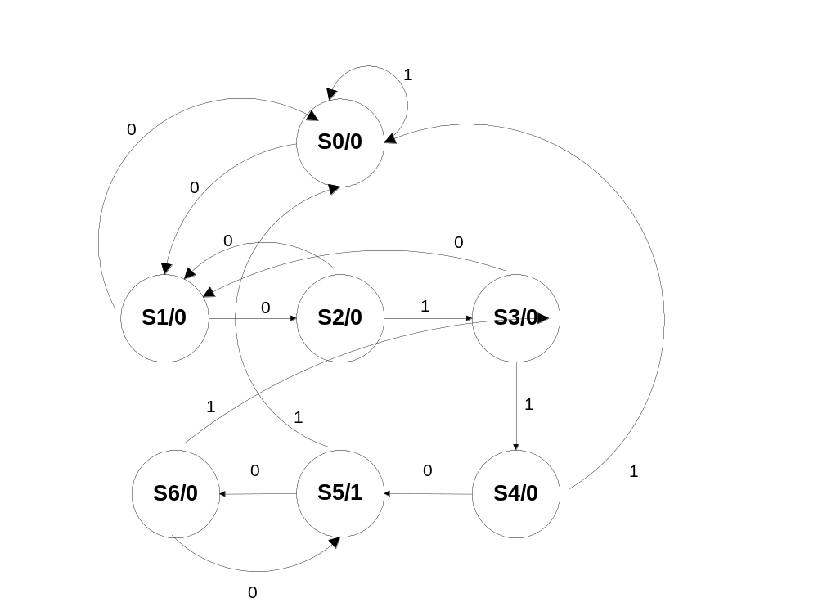

Diagram made with “MS Visio Pro 2002”.

If the pattern detector were created with a Mealy type of machine, the system would be harder to implement and it would have more complexity to the input and output.

In this Moore machine we can clearly illustrate the pattern detector. Every time that the machine is in state “S5” the signal is executed. From there we can go to states “S6” or “S0”.

The following table can express the transition diagram of the Moore diagram:

 | State | Present State |  | Next State |  | Output
 |  |  |  | X=0 | X=1
 | S0 | "000" |  | "001" | "000" | 0
 | S1 | "001" |  | "010" | "000" | 0
 | S2 | "010" |  | "001" | "011" | 0
 | S3 | "011" |  | "001" | "100" | 0
 | S4 | "100" |  | "101" | "000" | 0
 | S5 | "101" |  | "110" | "000" | 1
 | S6 | "110" |  | "101" | "011" | 0
 |  | Q2Q1Q0 |  | q2q1q0 | q2q1q0 | z

The next stage is to create the K-Maps for each of the qx’s:

 | q₂: |  | X
 |  | 0 | 0 | 0 | 0
 |  | 0 | 0 | 1 | 0 | Q₁
 | Q₂ | 1 | 0 | - | - | Q₁
 | Q₂ | 1 | 0 | 0 | 1
 |  |  |  | Q₀
q2 = Q2 x’ + Q1 Q0 x

 | q₁: |  | X
 |  | 0 | 0 | 0 | 1
 |  | 0 | 1 | 0 | 0 | Q₁
 | Q₂ | 0 | 1 | - | - | Q₁
 | Q₂ | 0 | 0 | 0 | 1
 |  |  |  | Q₀
q1 = Q1 Q0’ x + Q1’ Q0 x’
 | q₀: |  | X
 |  | 1 | 0 | 0 | 0
 |  | 1 | 1 | 0 | 1 | Q₁
 | Q₂ | 1 | 1 | - | - | Q₁
 | Q₂ | 1 | 0 | 0 | 0
 |  |  |  | Q₀
q0 = Q0’ x’ + Q1 Q0’ + Q1 x’

Following this K-Maps the output is clearly: Z= Q2 * Q0

For this lab we need 3 Flip Flops to create the 7 states used.

